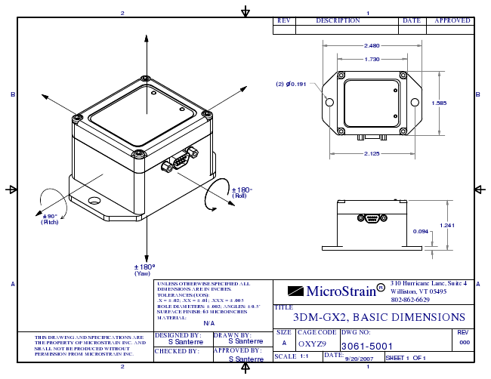
1 2
REV DESCRIPTION DATE APPROVED
2.480
1.730
(2) n0.191
B B
1.585
2.125
±180° (Roll)
(Pitch) `90°
0.094
±180° (Yaw)
THIS DRAWING AND SPECIFICATIONS ARE THE PROPERTY OF MICROSTRAIN INC. AND SHALL NOT BE PRODUCED WITHOUT PERMISSION FROM MICROSTRAIN INC.
SHEET 1 OF 1 2
1
1.241
A UNLESS OTHERWISE SPECIFIED ALL
310 DIMENSIONS ARE IN INCHES. TOLERANCES:(UOS): .X = ± .02; .XX = ± .01; .XXX = ± .005
MicroStrain R
Hurricane Lane, Suite 4 Williston, VT 05495 802-862-6629
A
HOLE DIAMETERS: ± .002; ANGLES: ± 0.5° SURFACE FINISH: 63 MICROINCHES MATERIAL:
N/A
TITLE
3DM-GX2, BASIC DIMENSIONS
DESIGNED S Santerre BY:
DRAWN S Santerre
BY:
APPROVED BY:
S Santerre
SIZE
CAGE CODE
DWG NO:
A
OXYZ9
3061-5001 SCALE
1:1
9/20/2007
REV
000 CHECKED BY:
DATE:

